Week 4 · Task 12 — SIEM Dashboards & Alerts
Intern name: Anush Deshar
Task: SIEM Dashboards & Alerts (Max score: 10)
Date: November 2026
Tools used: Splunk Free / Splunk Enterprise (trial), TryHackMe – Introduction to SIEM

1. Objective
A SIEM collects logs from many sources and lets analysts search them. On its own, though, a raw search is slow to read and nobody watches it all day. This task makes the SIEM useful in two ways: a dashboard that shows suspicious activity (failed logins) at a glance, and an alert that fires automatically when a brute-force pattern appears (more than 5 failed logins in 10 minutes).

2. TryHackMe Proof — Introduction to SIEM
I completed the free TryHackMe room Introduction to SIEM (7 tasks: Introduction, Logs Everywhere Answers Nowhere, Why SIEM?, Log Sources and Ingestion, Alerting Process and Analysis, Lab Work, Conclusion). The room shows Room completed: 100% with all seven tasks ticked.
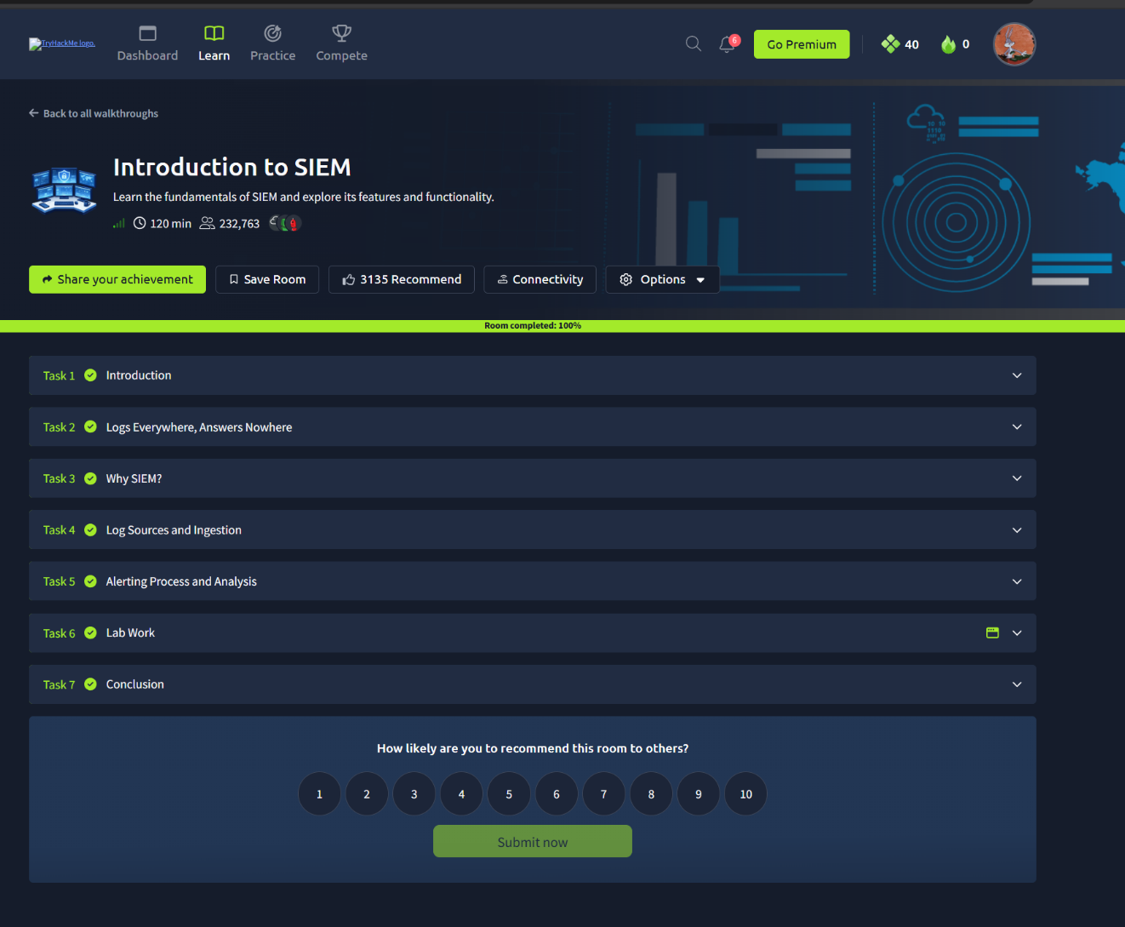
What I learned from the room:
- A SIEM centralises logs from endpoints, servers, firewalls and applications so they can be searched in one place.
- Logs go through ingestion, parsing and normalisation so that fields such as source IP, user and event ID can be searched consistently.
- Detection rules (correlation rules) turn searches into alerts, which an analyst then triages as true or false positives.
- Dashboards give a live summary of security-relevant data for monitoring.

3. Lab Environment
Item | Detail
SIEM | Splunk (Free / trial)
Data source | [Windows Security logs / Linux auth.log / sample
Index | main
Sourcetype | WinEventLog:Security or linux_secure

4. Part A — Search to Visualization

4.1 Base search
I first searched for failed login events.
For Windows Security logs (Event ID 4625 = failed logon):
index=main sourcetype=WinEventLog:Security EventCode=4625
For Linux authentication logs:
index=main sourcetype=linux_secure "Failed password"

4.2 Converting the search into a chart
I added timechart to count failed logins in 10-minute buckets:
index=main sourcetype=WinEventLog:Security EventCode=4625
| timechart span=10m count AS failed_logins
Then I opened the Visualization tab and chose a line chart (a column chart also works).

4.3 Converting the search into a table
To see which source addresses are responsible, I used stats:
index=main sourcetype=WinEventLog:Security EventCode=4625
| stats count AS failed_attempts BY src_ip, user
| sort - failed_attempts
This shows a table with the worst offenders at the top.

5. Part B — Dashboard with 2 Panels
I used Save As → Dashboard Panel to create a new dashboard called Failed Login Monitoring, then added the second panel the same way.
Panel | Search | Visualization | Purpose
1. Failed Logins Over Time | timechart span=10m count of failed logons | Line chart | Shows spikes that indicate brute-force attempts
2. Top Source IPs | stats count BY src_ip of failed logons | Table / bar chart | Identifies the attacking or misbehaving address
Steps followed:
- Ran the timechart search → Save As → Dashboard Panel → New dashboard "Failed Login Monitoring" → panel title "Failed Logins Over Time".
- Ran the stats search → Save As → Dashboard Panel → Existing dashboard → panel title "Top Source IPs".
- Opened the dashboard and arranged both panels.

6. Part C — Alert Configuration
Goal: alert when any single source has more than 5 failed logins within 10 minutes.

6.1 Alert search
index=main sourcetype=WinEventLog:Security EventCode=4625
| stats count BY src_ip
| where count > 5

6.2 Alert settings (Save As → Alert)
Setting | Value
Title | Brute Force – More than 5 Failed Logins in 10 min
Description | Detects a source IP with more than 5 failed logons within 10 minutes
Permissions | Private (or Shared in App)
Alert type | Scheduled — Run on Cron Schedule, every 10 minutes (*/10 * * * *)
Time range | Last 10 minutes
Trigger condition | Number of Results is greater than 0
Trigger | Once
Throttle | Optional: suppress for 10 minutes
Trigger action | Add to Triggered Alerts, Severity: High
Tip: if you used a real-time alert instead, state that and explain the difference (real-time uses more resources).

7. Part D — Testing the Alert and Trigger Proof
To test the alert I generated more than 5 failed logins in under 10 minutes.
- Windows: tried to log in (or run runas) with a wrong password 7–8 times.
- Linux: ran ssh wronguser@localhost with wrong passwords 7–8 times.
- Alternative: if no live logs are available, upload a sample log file containing repeated failed-login lines.
After the next scheduled run, I opened Activity → Triggered Alerts and confirmed the alert fired.

Observation
I generated [number] failed login attempts against [the user/account] from [the machine or IP] within about [number] minutes. The alert ran on its [10-minute] schedule and appeared under Activity → Triggered Alerts after roughly [number] minutes. It flagged the source IP with a count of number, which exceeded the threshold of 5.

8. Analysis
- Why a dashboard? Visuals reveal patterns, such as spikes, that are hard to see in thousands of raw log lines.
- Why an alert? Analysts cannot watch dashboards continuously; alerts notify them when a threshold is crossed.
- Threshold choice: 5 failures in 10 minutes catches brute-force attempts while ignoring a user who simply mistyped a password. In production this would be tuned to reduce false positives.
- Possible false positives: forgotten passwords, expired service-account credentials, misconfigured applications retrying with an old password.
- Next steps for response: check whether a success (Event 4624) followed the failures from the same IP, block or investigate the source, and force a password reset if needed.

9. Challenges Faced

Alert not firing: the schedule or time range didn’t cover the test events, or the trigger condition was set wrong, fixed by running the alert search manually and confirming the results were greater than 0. 10.Conclusion
I converted a failed-login search into a chart and a table, built a two-panel dashboard, configured a scheduled alert for more than 5 failed logins in 10 minutes, and confirmed it triggered during testing. This showed me how a SIEM moves from just storing logs to actively supporting detection and monitoring.

11. References
- TryHackMe — Introduction to SIEM
- Splunk Documentation — Create dashboards and alerts
- YouTube: Splunk dashboard tutorial for beginners; Splunk alert setup tutorial

